**INTERVIEW QUESTIONS FOR TABLEAU**

1. Which is not a component of Tableau
   1. VizQL Server
   2. Gateway
   3. Repository
   4. Tiles
2. Which Is a Tableau file extension
   1. .tdl
   2. .tdl
   3. .tde
   4. .tdi
3. Which is not a datatype available in tableau
   1. Text
   2. Date
   3. Region
   4. Character
4. Recognize a filter from tableau
   1. Context Filter
   2. Cross-Drill Filter
   3. Hide Filter
   4. URL Filter
5. Green Pill symbolizes Dimension
   1. True
   2. False
6. Which is not a Filter Pane in Tableau
   1. Condition Tab
   2. Slicer
   3. Wildcard Tab
   4. Exclude/Include Tab
7. Which of the following is not a Trend Line model
   1. Linear Trend Line
   2. Exponential Trend Line
   3. Binomial Trend Line
   4. Logarithmic Trend Line
8. Can the same measure be used twice in a single view
   1. No
   2. Yes
9. Which explains the order of data representation in data section
   1. Parameters > Sets > Measure > Dimension
   2. Measure > Dimension > Parameters > Sets
   3. Sets > Parameters > Dimension > Measure
   4. Dimension > Measure > Sets > Parameters
10. Sets can be created on Dimensions as well as measures?
    1. True
    2. False
11. Tableau cannot hide the unused fields.
    1. True
    2. False
12. Story Boards is the key feature of Tableau
    1. True
    2. False
13. Which of the following charts is best suited for Comparison
    1. Scatter Chart
    2. Pie Chart
    3. Line Chart
    4. Histogram
14. Best Visual for static values
    1. Pie Chart
    2. Stocked Column Chart
    3. Scatter Chart
    4. Bubble Chart
15. Which of the following chart will best depict sales of Audi, Mercedes, Bentley for the period of 3 years.
    1. Waterfall Chart
    2. Bubble Chart
    3. Line Chart
    4. Bar Chart
16. Identify continuous field
    1. Region
    2. Address
    3. Profit
    4. Ship Date
17. Which color is the dimension pill
    1. Blue
    2. Red
    3. Yellow
    4. Green
18. Tableau uses _________ chart by default to show time values
    1. Table
    2. Histogram
    3. Bar
    4. Line
19. Measures can be converted into dimensions
    1. True
    2. False
20. To view a discrete set of values in a continuous range of values which is an apt visual?
    1. Scatter Plot
    2. Line
    3. Histogram
    4. Waterfall
21. Pick a file extension for tableau projects
    1. Tableau Packaged Workbook [.twbx]
    2. Tableau Workbook [.twb]
    3. Tableau Data Source [.tds]
    4. All of the above
22. Which should be picked to place on the colors card
    1. PostalCode
    2. Discount
    3. Region
    4. Quantity
23. Do I need to write a separate calculation for viewing top 10 Cities with maximum sales?
    1. Yes
    2. No
24. A sheet cannot be used within a story directly.
    1. True
    2. False
25. Sets can be created on dimensions?
    1. True
    2. False
26. # in tableau shows?
    1. Data Literal
    2. Measure
    3. Dimension
    4. Parameter
27. Macro is a concept of Tableau
    1. True
    2. False
28. Which does not belong to the Product suite that tableau offers?
    1. Reader
    2. Desktop
    3. Private
    4. Public
29. Is there a QnA feature in Tableau?
    1. Yes
    2. No
30. Is there a drill up/ drill down feature in tableau?
    1. Yes
    2. No
31. Which is not a join available in tableau?
    1. Inner
    2. Outer
    3. Left
    4. None of the above
32. DAX functions belong to tableau
    1. True
    2. False
33. Tableau gives you access to additional marketplace?
    1. Yes
    2. No

### What is the meaning of forecast option in analysis menu

* 1. Used to export an img of the story
  2. To show forecast based on available data
  3. Is used to set the layout in terms of colors
  4. To update the story with latest data from source

1. What is the meaning of maps layers option in the map menu
   1. To show forecast based on available data
   2. To hide and show map layers, such as street names and country borders and add data layers
   3. To create new geographic roles and assign them to the geographic fields in your data
   4. Is used to create additional fields based on certain calculation on existing fields
2. If you publish your data to tableau public, who can view it?
   1. Open to everyone
   2. Only people with a license

### Does dashboards contain multiple worksheets which are linked. so the action in any of the worksheet can change the results in the dashboard accordingly?

* 1. Yes
  2. No

1. View could be highlighted using?
   1. Filters
   2. Aggregations
   3. Labelling
   4. All of the above.
2. Which is not a shelf from Tableau
   1. Row and Column
   2. Filter
   3. Parameter
   4. Marks
3. What is the meaning of geocoding option in map menu?
   1. Is used to export an image of the story
   2. To create new geographic roles and assign them to the geographic fields in your data
   3. Is used to set the layout in terms of colors and sections of the story
   4. To hide and show map layers, such as street names and country borders and add data layers
4. Identify shelf from Tableau
   1. Data
   2. Pages
   3. Report
   4. Model

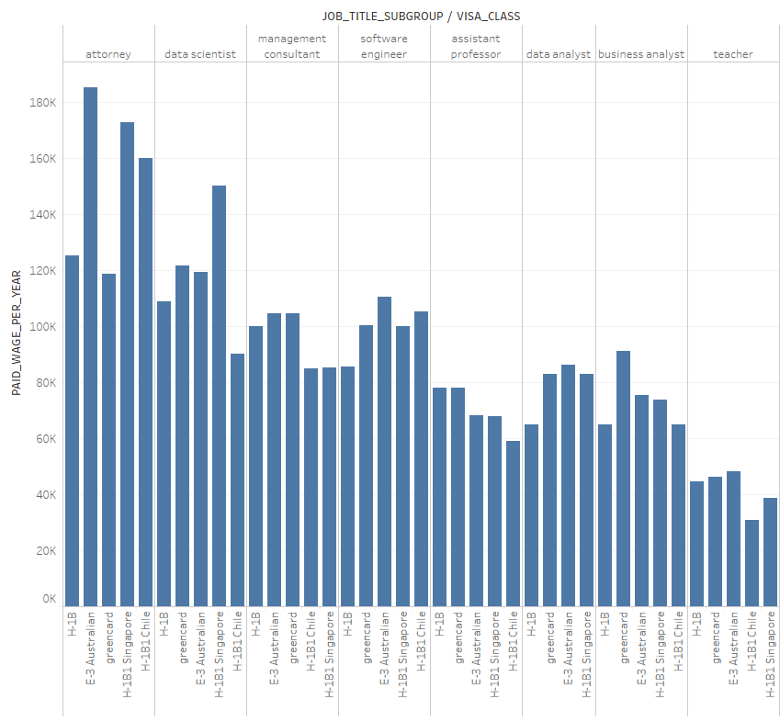

Answer the following questions related to the chart above.

1. What should be placed in the row shelf?
   1. PAID_WAGE_PER_YEAR
   2. VISA_CLASS
   3. JOB_TITLE_SUBGROUP
   4. Cannot comment
2. What should be placed on the column field
   1. PAID_WAGE_PER_YEAR
   2. VISA_CLASS
   3. JOB_TITLE_SUBGROUP
   4. Cannot comment
3. Which visual chart is used?
   1. Basic Bar Chart
   2. Combo Bar Chart
   3. Dual Axis Bar Chart
   4. Clustered Bar Chart
4. Which is a valid statement
   1. Citizen with green card have the highest paid wages
   2. Data Scientist with green card are paid more wages than combined avg of H1B1-Singapore and H1B1-Chile
   3. Data Analyst with E3-Australian Visa is paid the least
   4. None of the above
5. Data Analyst with E3-Australian Visa is paid the highest
   1. True
   2. False
6. After which Layer does tableau fit in the below option
   1. Database Layer
   2. Data Interaction Layer
   3. Data Modelling Layer
   4. Service Layer
7. Personal Version is preferred for Big Data.
   1. True
   2. False
8. Tableau Server is Located in
   1. Europe
   2. Australia
   3. Dubai
   4. Canada
9. Discrete Variables are also called as Measures
   1. True
   2. False
10. Continuous Variables are also called as Measures
    1. True
    2. False
11. Dependent Variables are usually all Measures
    1. True
    2. False
12. Tableau provides a default model view
    1. True
    2. False
13. Creation of Custom Filters is possible with Tableau?
    1. True
    2. False
14. Best way to find Outliers is?
    1. Manually search in the table
    2. Filter directly on the data source and delete
    3. Using trend analysis by forming groups & filters
    4. Does not affect the analysis
15. Sum[x,y] falls under which type of calculation
    1. Number
    2. Aggregate
    3. Logical
    4. User
16. Variables in calculation field are represented with
    1. Orange
    2. Green
    3. Blue
    4. Red
17. Blue fields in the calculations are aggregates
    1. True
    2. False
18. # represents ____________ in Tableau.
    1. Parameter
    2. Group
    3. Calculation Field
    4. Dimension
19. Newly created Calculated Fields are listed under Dimension
    1. True
    2. False
20. Newly created Calculated Fields are listed under Measures
    1. True
    2. False
21. The data source uploaded initially is always
    1. External data source
    2. Primary Data Source
    3. Secondary Data Source
    4. Internal Data Source
22. Tableau allows dynamic selection of primary and secondary data sources?
    1. True
    2. False
23. Dashboard is a feature unique to tableau?
    1. True
    2. False
24. A good reason to use bullet graph is?
    1. Displaying sales growth
    2. Adding data to bins and calc. Count measure
    3. Analyzing the trend for a time period
    4. Comparing the actual against the target sale
25. The icon associated with the field that has been grouped is a ______________
    1. Paper Clip
    2. Set
    3. Hash
    4. Equal To
26. What is the meaning of the cell size option in format menu
    1. To customize the size of the cells displaying data
    2. To assign a title and caption
    3. To create additional fields based on calc.
    4. Apply theme to the entire workbook
27. What does publishing data source mean?
    1. To export an image of story
    2. To publish the workbook in the server used by others
    3. To publish the source data used in the workbook
    4. Used to give a chance to user for dynamically changing data members at runtime.
28. Can you create your own Hierarchy in tableau?
    1. True
    2. False
29. Can we create different worksheets to create different view on the same data or different data.
    1. Yes
    2. No
30. .Twb format allows the stakeholders to directly view the report with data imports?
    1. True
    2. False
31. Which of the following is not an advantage of tableau?
    1. Widely used by Data Analyst
    2. Story Feature
    3. Multiple visual creation on the same sheet
    4. Wide option available to import large dataset
32. Which is not a practice around dimensions and measures
    1. Double Click
    2. Drag and Drop
    3. Point and Click
    4. None of the above
33. Is a manual sort possible in Tableau
    1. True
    2. False
34. Visual Chart suggestion is not a default feature of Tableau
    1. True
    2. False
35. Customization of Axis Header is possible with Tableau
    1. True
    2. False
36. At a time only a single field can be created using highlighter.
    1. True
    2. False
37. Screen Dimension are customizable in Tableau
    1. True
    2. False
38. Tableau is best fit for?
    1. Visual Drag n Drop operation
    2. Data Discovery
    3. Statistical Modelling
    4. ETL Operations
39. Is it possible to deploy a URL action on a dashboard object to open a Web Page within a dashboard rather than opening the system’s web browser?
    1. True, with the use of Tableau Server
    2. True, with the use of a Web Page object
    3. False, not possible
    4. True, requires a plug-in
40. A sheet cannot be used within a story directly. Either sheets should be used within a dashboard, or a dashboard should be used within a story.
    1. True
    2. False
41. Sets can be created on Measures.
    1. True
    2. False
42. Tableau is not capable to?
    1. Wizard driven visual analysis
    2. Centralized server
    3. Ad-hoc discovery
    4. None of the above
43. For creating variable size bins we use _____________
    1. Calculation Fields
    2. Sets
    3. Groups
    4. Table Calculation
44. What is the below graph called?

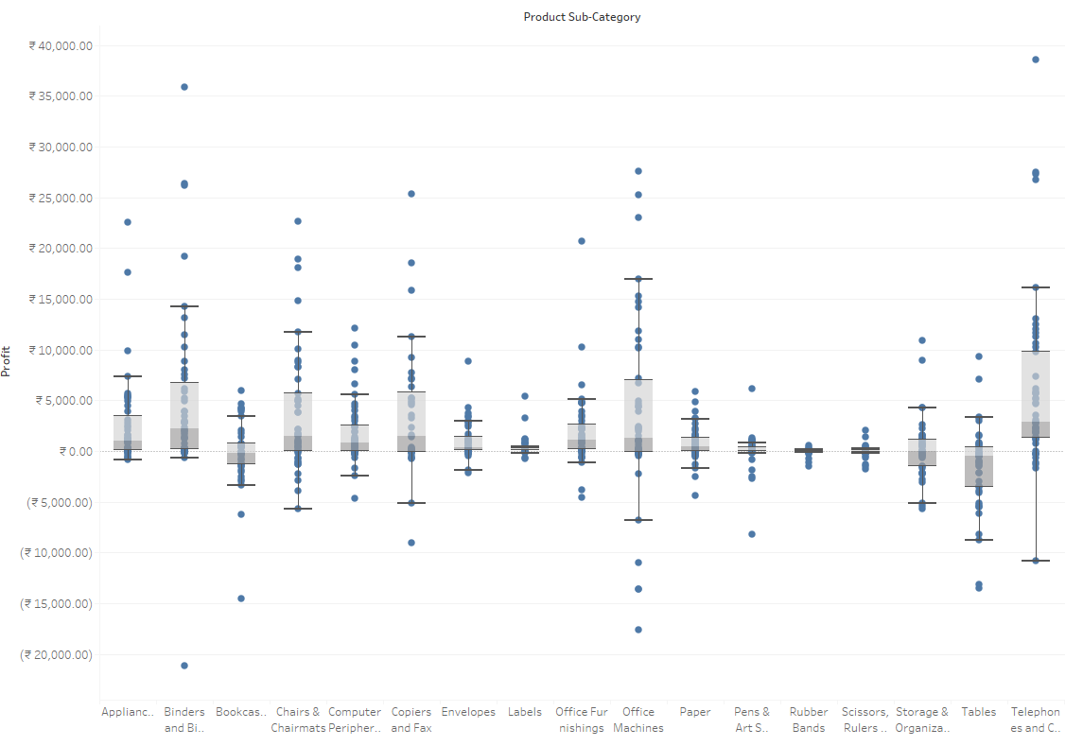

* 1. Candle PLot
  2. Scatter Line Plot
  3. Box Plot
  4. Cylinder Plot

1. Longitude and Latitude are to be created externally by the analyst?
   1. True
   2. False
2. Sales/Profit can be considered as a continuous field?
   1. True
   2. False
3. Swapping rows with columns on a dual axis graph will throw an error.
   1. True
   2. False
4. Customizing donut chart is a default feature in tableau.
   1. True
   2. False
5. Can Measures can be converted to dimensions ?
   1. True
   2. False
6. By default all numeric values are listed under measures
   1. True
   2. False
7. Which is not a strength of Tableau
   1. Mobility
   2. Self Service BI
   3. Big Data Connectivity
   4. Enterprise Deployment
8. Treemaps are static, No grouping of categories is possible.
   1. True
   2. False
9. Customizing tooltip to visuals on hover is a feature available in Tableau
   1. True
   2. False
10. R functions and R models are used in Tableau?
    1. True
    2. False
11. Data blending is used for?
    1. To merge data from the same source
    2. To merge data two different folders in the same location.
    3. To merge data placed in different locations.
    4. None of the above
12. Can you automate the tableau reports?
    1. Using Tableau Public
    2. Using Tableau Online
    3. Using Tableau Desktop
    4. Using Tableau Server
13. Which function is used to check the current date and time?
    1. ISDATE()
    2. CURRENTDATE()
    3. NOW()
    4. DATE()
14. Which is not a valid file extension for tableau
    1. .tds
    2. .tbm
    3. .tdl
    4. .tps
15. Which is not a data type in tableau?
    1. String
    2. Text
    3. Number
    4. Date
16. Which of these methods saves all worksheets in your visualization
    1. Worksheets
    2. Workbooks
    3. Bookmarks
    4. Dashboards
17. Can one visual chart have two x-axis or y-axis?
    1. Yes
    2. No
18. Tableau supports live data connection
    1. Yes
    2. No
19. Drill down can be only performed if there is an existing hierarchy in the workspace?
    1. Yes
    2. No
    3. May be
20. Extraction of data after filtering from a data source is possible?
    1. Yes
    2. No
21. Groups can be formed random like clusters?
    1. True
    2. False
22. Sets is used for individual clustering while creating a visual
    1. Yes
    2. No
23. Grouping is limited to columns with hierarchy?
    1. True
    2. False

1. What does creating alias in tableau mean?
   1. Creating same columns with different column names
   2. Having same column name but different name for column elements
   3. Means to rename measure
   4. None of the above
2. Which is a license that tableau offers
   1. Tableau Desktop License
   2. Tableau Public License
   3. Tableau Viewer License
   4. Tableau CAL License
3. Alias should be created with measure.
   1. True
   2. False
4. Alias are used under dimensions usually?
   1. True
   2. False
5. Grouping is best defined as?
   1. Collection of similar elements
   2. Customized collection of elements
   3. Unique collection of elements.
   4. Random collection of elements
6. Group icon is
   1. HashTag
   2. Paper clip
   3. Tree
   4. Abc
7. Tableau supports data extracts from?
   1. MySql
   2. Postgres
   3. MS Sql Server
   4. All of the above
8. Grouping will overwrite the existing values of that particular dimension.
   1. True
   2. False
9. Grouping can be used as a normal dimension
   1. True
   2. False
10. Grouping in measure is possible?
    1. True
    2. False
11. Sets can be combined?
    1. True
    2. False
12. Joining of sets is same as data blending
    1. Yes
    2. No
13. Data type of both set must be same is a requirement of Tableau
    1. Yes
    2. No
14. Shared axis in Tableau is for ?
    1. Two Measures
    2. Two Dimensions
    3. Two Sets
    4. Two Group
15. Which of the following is not a filtering option in tableau
    1. Top
    2. Condition
    3. Wildcard
    4. None of the Above
16. Default aggregation used for tree map
    1. Sum
    2. Avg
    3. Count
    4. Count Distinct
17. Tableau is supported on a mobile device
    1. True
    2. False
18. Tableau allows you to join multiple as per your flexibility
    1. Yes there is no limit
    2. Yes but the limit is 27
    3. There is a possibility but the limit is above 50 Tables
    4. No is not feasible, the limit is 32
19. Testing is a latest add on feature offered by tableau before the visualization stage
    1. True
    2. False
20. Tableau supports SQL queries?
    1. Yes
    2. No, not yet added.
21. Select the one that census info in geocoding option
    1. Tableau Server
    2. Longitude, Latitude
    3. Metadata
    4. Data Layer in geospatial analysis
22. Cascading filters are same as joining of sets
    1. Yes
    2. No
23. Tableaus performance is dependent on?
    1. Data source
    2. Data Geographical location
    3. Time the data source takes to execute query
    4. None of the above
24. Select one which is compatible with Tableau
    1. Python 2
    2. Python 3
    3. Java
    4. R
25. Tableau SDK is downloaded within the tableau set up file
    1. True
    2. False
26. Tableau SDK is an add on kit for?
    1. Building RESTful API
    2. Connect to a data source
    3. Eclipse, Visual Studio
    4. All of the above
27. Which is included in Tableau SDk
    1. Extract API
    2. Server API
    3. Both
    4. None of the above
28. Tableau SDK supports?
    1. C, C++
    2. Python 2.x and Python 3.x
    3. Java
    4. All of the above
29. Tableau SDK does not work on
    1. Fedora
    2. CentOS
    3. Ubuntu
    4. None of the above
30. Tableau SDK is compatible with which OS
    1. Windows
    2. Linux
    3. Mac OS X
    4. All of the above
31. Updates from the data source
    1. Is it auto updated
    2. Manual updation is required
    3. We can customize the option
    4. None of the above
32. Custom geocoding can be used to plot data on the map?
    1. Yes
    2. No
33. In Mobile views dynamic scrolling can be attained
    1. True
    2. False
34. Tableau follows which schema
    1. Hybrid
    2. Snowflake
    3. Star
    4. None of the above
35. Which filter is applied at the data source level?
    1. Context Filter
    2. Quick Filter
    3. Local Filter
    4. Global Filter
36. Which table calculation shows the rate of change?
    1. Percentage difference from
    2. Difference from
    3. Percent from
    4. Percentage of total
37. What is a invisible filter?
    1. Can be applied to view but not exposed to user
    2. Filter is only displayed with correct data blending
    3. Type of filter in tableau used for dashboard design
    4. None of the above
38. Which of the following allow users to select or input a value in a view and that value can then in turn be used in calculations, and subsequently, filters.
    1. Calculated fields
    2. Captions
    3. Parameters
    4. Tooltips
39. Dashboard layout containers allow you to __________
    1. Create an area in the dashboard where objects automatically adjust their size and position based on the other objects in the container
    2. Create an area in the dashboard where objects maintain its predetermined size and position.
    3. Add sheets and other objects in the dashboard without affecting any formatting
    4. Add a dashboard within a dashboard
40. Where can the list of parameters not be used
    1. Filters
    2. Binned Measures
    3. Reference Line
    4. Pages
41. Sorted field is denoted in?
    1. Green
    2. Blue
    3. Italic
    4. Bold
42. Containers for shelves, Legends and other control are represented as?
    1. Cards
    2. Shelves
    3. Marks
    4. Page
43. Which shelf allows you to encode data by assigning different shapes to the marks in a data view
    1. Icon shelf
    2. Shape shelf
    3. Label shelf
    4. Page shelf
44. Displays the fields of the data sources to which Tableau is connected. The fields are divided into dimensions and measures. It also displays custom fields such as calculations, binned fields, and groups
    1. Data Window
    2. Dashboard
    3. Data Source
    4. Bookmarks
45. Text tables is well known as
    1. Axis
    2. Cell
    3. Caption
    4. Cross Tab
46. Is a representation of your data in a Tableau worksheet or dashboard.
    1. Dimensions
    2. Data Window
    3. Data view
    4. Data source
47. What is a secondary Table calculations
    1. Calculations performed from the results of the previous calculations
    2. Calculations that applies to all of the data in the table
    3. Another name for calculated field
    4. Calculations performed at the data source level
48. In dual axis which is a good practice
    1. Edit Axis
    2. Dual Axis
    3. Sync Axis
    4. Format Reference Line
49. What is presentation mode?
    1. A view from a user’s perspective.
    2. Removes legends, quick filters, parameter controls to allows easy integration with Power Point
    3. Read only version of your view
    4. Hides the data window, toolbars, workspace controls, and view cards
50. Tableau supports all browsers
    1. True
    2. False
51. Which is an option for wildcard filter
    1. Contains
    2. Starts with
    3. Ends with
    4. All of the above
52. Calculated fields are represented as an equals
    1. True
    2. False
53. All items in the data pane must have unique value
    1. True
    2. False
54. Parameters can have the same names?
    1. Yes
    2. No
55. Count and CountD null values are included
    1. True
    2. False
56. When using DATEPART, which of the following is not a valid value?
    1. Months
    2. Days
    3. Dayofyear
    4. Is-Weekday
57. DATE(2018-12-11 22:12:09) is a valid expression?
    1. True
    2. False
58. ZN function returns?
    1. Zero when TRUE
    2. Returns value is exist else returns NULL
    3. Returns value is exist else returns zero when Null
    4. Returns 1 if is a value else returns null
59. Which is not a valid function
    1. RUNNING_COUNT
    2. RUNNING_COUNTD
    3. RUNNING_SUM
    4. RUNNING_AVG
60. SCRIPT_function returns result from an external service
    1. True
    2. False
61. IF part of an expression can return a different data type from the ELSE part.
    1. True
    2. False
62. The LOOKUP function
    1. Returns the number of rows from the current row to the first row in the partition.
    2. Returns the value of the expression in a target row, specified as a relative offset from the current row.
    3. Returns the number of rows from the current row to the last row in the partition.
    4. Returns the value of this calculation in the previous row.

***Subjective Questions :***

1. What Are the Filters? Name the Different Filters in Tableau.

Tableau filters are a way of restricting the content of the data that may enter a Tableau workbook, dashboard, or view. The Different Types of Tableau Filters are:

1. Extract filters
2. Context filters
3. Data source filters
4. Filters on measures
5. Filters on dimensions
6. Table calculation filter
7. There Are Three Customer Segments in the Superstore Dataset. What Percent of the Total Profits Are Associated with the Corporate Segment?
   1. Steps :
8. Drag segment field to the rows shelf. Here, segment consists of Consumer, Corporate, and Home Office
9. Double-click on the profit field under Measures.
10. Right-click on SUM (Profit) under marks card, select Quick Table Calculation and click on Percent of the total.
11. Different joins available in Tableau?
    1. Inner
    2. Left
    3. Right
    4. Outer
    5. Union
12. What is the Difference Between Joining and Blending?

Combining the data from two or more different sources is data blending, such as Oracle, Excel, and SQL Server. In data blending, each data source contains its own set of dimensions and measures. Combining the data between two or more tables or sheets within the same data source is data joining. All the combined tables or sheets contain a common set of dimensions and measures.

1. Is There a Difference Between Sets and Groups in Tableau?

A Tableau group is one dimensional, used to create a higher level category by using lower-level category members. Tableau sets can have conditions and can be grouped across multiple dimensions/measures.

1. What is a Parameter in Tableau? Give an Example.

A parameter is a dynamic value that a customer could select, and you can use it to replace constant values in calculations, filters, and reference lines.

For example, when creating a filter to show the top 10 products based on total profit instead of the fixed value, you can update the filter to show the top 10, 20, or 30 products using a parameter.

1. What is the Rank Function in Tableau?

The ranking is assigning something a position usually within a category and based on a measure. Tableau can rank in several ways like:

* rank
* rank_dense
* rank_modified
* rank_unique

1. Define aggregation and disaggregation in a tableau?

They both are the ways used to develop a scatterplot in order to measure and compare data values. Aggregation, as the name suggests, is the calculated form of a specific set of values that return a single numeral value. For instance, a set of values such as 1, 3, 5, 7 will return the value. The default aggregation like sum, median, average, count, etc. is not user-defined. Disaggregating data is used to refer to viewing every data source row and analyzing data both dependently as well as independently.

1. What is a context filter and what are its limitations?

It makes the filtering process smooth and straightforward. It is used to establish a filtering hierarchy where all the present filters are used to refer to context filters while other filters process the data which has been already passed by the context filter. More than one context filter creation is used to improve performance as extra filters are not created and thus the query execution time is also maintained. This can be created by dragging the field into filters tab and right click on the field and select “Add to context”. Limitations of context filter: By default time is taken to place a filter in context. A temporary file is created as soon as the filter is set to context one for that context filter. The table will reload every time and it will contain the values not filtered by either context filter or by custom SQL filter.

1. What are Schedules and Extracts in a Tableau server?

Data extracts are the first subdivisions or copies of actual data from original data sources. The workbook using data extracts instead of living connections is faster. After the extraction of data users can publish their workbook. Scheduled refresh is the scheduled task set used to refresh the data extract. This saves from the effort of republishing the workbook every time the data gets updated.

1. Name the components of the dashboard?

Horizontal, Vertical, Text, Image Extract, Web[URL ACTION]

1. What is the page shelf?

It is a distinct and powerful tool to control the output display. It fragments the view into the line of pages thereby giving a different view on every page. This minimizes the scrolling and makes it more user-friendly. The pages can be flipped through specific controls and compared at the common axle.

1. What is the maximum number of tables that can be joined?

A maximum of 32 tables can be joined.

1. What are shelves and sets?

Shelves are named areas to the left and to the top of the view. Views are built using fields by placing them onto shelves. Sets, on the other hand, are the custom fields used to define a data subset primarily based on conditions. A set can be based upon a specific computed condition. For example, a set contains customers with sales more than a particular threshold. These sets get updated as and when your data changes.

1. Display top 5 and last 5 records in a single view?

You need to create two sets. The first one containing the top 5 records while the other one with bottom 5. Then join these two sets by displaying a total set of 10 records.

1. Why we Need Actions in Tableau?

Actions in Tableau bring more interaction to the users which they are working in the dashboard or workbook. It will set up by clicking the right actions for the particular data.

1. Difference between parameters and filters

Parameters are dynamic values that can replace constant values in calculations. Parameters can serve as Filters as well. Filters, on the other hand, are used to restrict the data based on a condition that we have mentioned in the Filters shelf.

1. What is the difference between the quick filter and the normal filter in Tableau?

Quick filter is used to view the filtering options and can be used to select options. Whereas, the Normal filer is something with which we can limit the options from the list or use some conditions to limit the data by field or value.

1. How can we combine a database and the flat file data in Tableau Desktop?

Connect data twice, once for database tables and then for the flat file. The Data->Edit Relationships. Give a Join condition on the common column from DB tables to the flat file

1. How do we use parameters in Tableau?

We can use parameters with filters, calculated fields, actions, measure-swaps, changing views, and auto-updates.

1. What is a blended axis?

Here, multiple measures are shown on a single axis, and all the marks are shown in a single pane.

Drag a dimension in a column

Drag the first measure in the column

Drag the second measure in the existing axis

Us/multiplemeasures_blendedaxes.html

1. List the various datatypes in Tableau?

Various data types in the tableau are: 1) Boolean, 2) date, 3) date and time, 4) geographical values, and 5) text/string, number.

1. Difference between data joining and data blending

Joining is a term that is used when the user combines data from the same source like tables in oracle or excel file while Blending needs two completely defined data sources report

1. What are context filters?

A Context filter is an independent filter that can create a separate dataset out of the original data set and compute the selections made in the worksheet. One or more categorical filter that separates the dataset into major parts can be used as a context filter. All other filters used in the worksheet works based on the selection of context filter. The functions of context filters can be explained through an excel sheet.

1. Explain the term filter actions

Filter actions show related information between a source sheet and one or more target sheets. This type of activities best suited when a developer is building a guided logical path using a workbook or in a dashboard.

1. Bar graph vs Histogram

A bar chart majorly represents categorical data (data that has some labels associated with it), they are usually represented using rectangular bars with lengths proportional to the values that they represent. While histograms, on the other hand, is used to describe distributions.

1. What are the types of Tableau combined sets?

* All members in both sets: This is an option to combined set that holds all the members from left as well as right set.
* Shared members in both sets: This option holds matching members from both left and right sets. It means every record must match the condition present in these sets.
* Left set except shared members: This Tableau set is used to hold all the members from the left set except matching members from the right set.
* Right set except shared members: It holds all the members from the right set by matching members from the left set.

1. Explain the classification of tableau

* Developer Tools: The Tableau tools that are used for development, such as the creation of dashboards, charts, report generation, visualization, fall into this category. Tableau products, under this category, are the Tableau Desktop and Tableau Public.
* Sharing Tools: As the name suggests, the purpose of the tool is to share the visualizations, reports, dashboards that were created using the developer tools. Products that fall into this category are Tableau Online, Server, and Reader.

1. TreeMap Vs Heat Map

TreeMap represents and shows data hierarchically as a group of nested rectangles.It can be used for comparing the categories with size, colors, and illustrating the hierarchical data. Heat Map represents the data graphically with multiple colors to represent values.It can be used for comparing the categories depend on size and color.

1. What is the use of a blended axis?

Blended axis is used to blend measures that share the axis when they have the same scale.

1. What is the use of dual-axis?

Dual Axis enables users to compare measures. It is useful when they like to compare two measures having different scales.

1. Explain bin

Bin is a user-defined set of data that are of the equal interval that stores data values according to or which fits in bin size.